### **SINGAPORE POLYTECHNIC**

### **SCHOOL OF BUSINESS**

### **AY2022/2023, SEMESTER 1**

|  |  |
| --- | --- |
| EP0706 Introduction to Psychology |  |

# CA3 Submission Phase 2

|  |  |
| --- | --- |
| Student information | |
| Student Name | Justin Wong Juin Hng |
| Admin No | P2112646 |
| Class | EL/FT/EP0706/06 |
| Tutor’s Name | Ms Brenda |

This list has **five** topics. You are required to choose any **four** topics for submission. Of the four chosen topics, mark an “X” on the **two** topics that you wish to be graded. The final score is the cumulative scores of the three graded topics.

All research materials included in the journal are to be cited and referenced using (APA/Harvard) citation style.

|  |  |  |
| --- | --- | --- |
| **Number** | **Topic**  **(Write any FOUR topics)** | **Choose any TWO topics to be graded**  **- Indicate the two topics by putting an “X” next to the topic in this column.** |
| 4. | Social Learning Theory |  |
| 5. | Developmental Psychology | X |
| 6. | Sensation & Perception | X |
| 7. | Memory |  |
| 8. | Socio-Cultural Psychology |  |

**SUBMISSION DEADLINE:**

The submission deadline for Phase 2 is in **Term 2 Week 6** during your respective tutorials.

Work submitted after this deadline will receive 50% of the marks awarded. If you have a LOA, you are to submit the assignment immediately after the end of the LOA. The maximum time allowed is 7 days after the deadline.

Work submitted 7 days (including Saturday and Sunday) after the deadline will neither be accepted nor graded. You will not be entitled to earn any marks for this submission.

**Integrity Statement:**

*Academic Integrity is a central tenet of Singapore Polytechnic. The polytechnic examination rules state “*Cheating in examinations and other assessed work is a very serious offence.  This includes copying and using plagiarised material.  Any student, who cheats, attempts to cheat or breaches any rules for examinations and tests will face disciplinary action.  The student is liable to be expelled.”

*All students are expected to complete this work with integrity. This includes not sharing your journal with any student taking the module this semester.*

*Please sign below affirming that this work is your own and has been conducted with full integrity.*

Name and Signature

Justin Wong

___________

**Topic 1**

Name: Justin Wong Juin Hng

Admin No. p2112646

Topic Name: The Role of Social Learning Theory in Education

|  |  |
| --- | --- |
|  | **Tutor’s Qualitative Comments Only** |
| Content |  |
| Language |  |
| Organisation & Format |  |
| Visuals |  |

**Begin your Learning Journal here:**

What is SLT?

When we think of the phrase Social Learning, a brief understanding of the idea comes to mind, learning in a social environment. Let us break down the definition and understand how Social Learning Theory works.

Social learning is a theory of learning process social behaviours which proposes that new behaviours are acquired by observing and imitating others. (Bandura, 1971) Social learning theory is a cognitive process that occurs in a social setting, as opposed to being purely behavioural.

Behaviourism is a branch of psychology that deals with the actions of people based on external environmental influences, whereas cognitive psychology is based on the thought process that alters a person's behaviour (Difference Between, n.d.)

Learning is a complicated process influenced by numerous factors. Observation can play a critical role in determining how and what children learn. People are like sponges, soaking up experiences they have daily. (Cherry, 2021)

Due to the complexity of learning, there are many theories to explain how and why we learn. Hence, psychologist Albert Bandura proposed a concept of Social Learning Theory suggesting observation and modelling play a primary role in this process. (Cherry, 2021)

How does SLT work?

The process of SLT can be summarised into four stages. Attention, Retention, Reproduction and Motivation.

Attention: The degree to which we notice the behaviour. A multitude of conditions can affect this degree.

- Energy level

If the person is sleepy, they are less likely to be able to pay attention to the task at hand

- Characteristics of the Model

Characteristics of the model influence the observer’s attention. Bandura and others have shown that humans pay more attention to models that are attractive, like them, or prestigious and are rewarded for their behaviours.   
(Stone, 2017)

Retention: The degree to which we remember the behaviour. We cannot perform the behaviour if we do not remember the behaviour. While behaviour may be noticed, if a memory is not formed, the observer will not perform the behaviour. Since Observational Learning does not occur immediately, the ability to retain information is key for the replication of behaviour.

Reproduction: The ability to replicate the behaviour. After noticing and remembering the behaviour, the person will try to replicate the behaviour. This is limited by their physical and mental capacity to do so. If a child watches their parent drive a car, they too will want to replicate that behaviour. However, they will be unable to do so as they are not old enough to do so.

Motivation: The will and want to reproduce the behaviour. It involves learning through observing the consequences of actions for other people, rather than through direct experience. Incentivisation and punishment can come in the form of negative or positive reinforcement and can function as a rationale for the motivation to want to reproduce the behaviour.

An example of SLT

I have always had an interest in cars. Many hours were spent at TimeZone racing car games, and many more were spent at home on my simulator.

My home simulator

As you can tell, it is a pretty serious setup. And it is pretty expensive too.

I was trying to master my way around the Singapore Grand Prix Circuit, but I could not figure out for the life of me, what to do. I tried a multitude of ways and methods to find speed but to no avail. Hence, I decided to head over to Legion of Racers at Kallang for tips.

Upon reaching the venue, I noticed a patron racing on the simulator at the Singapore Circuit! I quickly headed over to him and proceeded to ask him about some tips that he had. He proceeded to explain them to me, bit by bit.

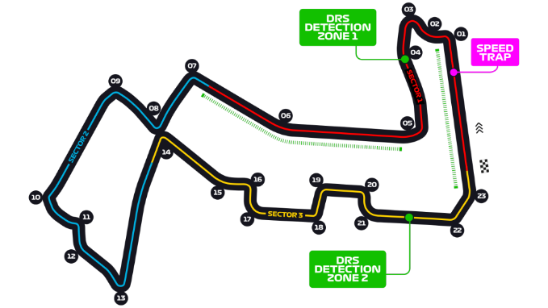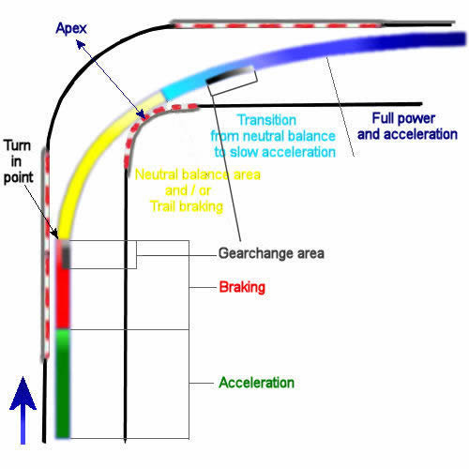

Figure 1 Singapore GP Map (www.formula1.com, n.d.) Figure 2 Explanation of racing line (www.formula1-dictionary.net, n.d.)

He explained to me that I was braking too early, and that caused me to mess up my turn, and thus I lost valuable time on track. He further elaborated by saying that this was occurring multiple times and at different corners, and that all my mistakes compounded up to result in slower lap times.

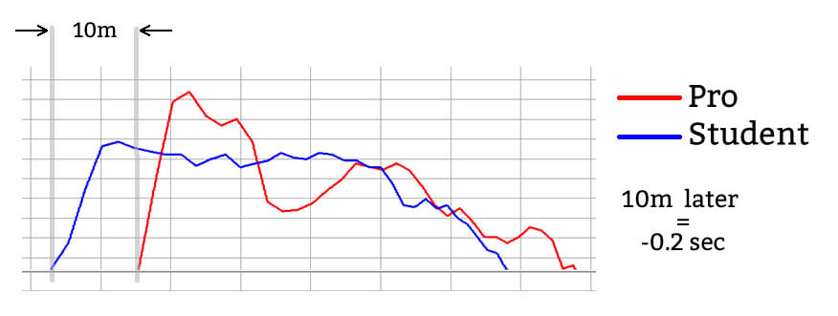 This is a comparative speed graph between a pro like him compared to a student like me. It shows the difference in consistency between a pro and a student. If a pro averages 0.2 seconds faster per corner, that is upwards of 4.6 seconds faster per lap. Since lap times are counted in the range of tenths of a second. That could mean the difference between first and last place!

Figure 3: Example brake trail of student vs pro (Driver61, 2019)

Knowing that he was much faster than me, was an incentive for me to listen and pay attention to what he said. All the tips, guides, and handy dandy bites of information were all floating through my head. If I wanted to be able to master this Circuit, I needed to be able to remember and retain all this information. I did not trust my short-term memory to be able to retain everything he said. Hence, I wrote down all the tips on my phone.

“Brake later, turn later, slowly let go of the throttle, be gentle on the brakes.”

After writing down all the tips and clarifying with him the rationale and meaning, he asked me if I wanted to give it a shot. I was surprised to say the least, as he was already comfortable sitting down. But since he insisted, I sat down in the racing seat and hoped for the best.

I tried to visualise what he was doing before I approached him. The way his hands rotated around the steering wheel at such a precise angle, the way his feet were smoothly controlling the throttle and the brakes—the way every turn was perfectly executed. I tried to retain all that in my memory whilst recalling what he mentioned.

As I began my run, it was incredibly tough to keep all that in my head whilst managing my race. However, with his encouragement, I gave it another go. And another go after that. Slowly bit by bit, I could see myself becoming like him. I was able to replicate the turns and imitate the brakes, just like he said.

Soon after, I gave it one final go. Zooming past the Esplanade at 240km/h, I could feel the thrill and anticipation as I approached the final corner. I braked late, turned late, and crossed the line.

“1 minute and 40 seconds.” He spoke. I was a full second faster than him.

It filled me with so much joy and motivation, knowing that I could do it. All the effort paid off! From standing behind him and paying close attention, to trying to remember and recall his actions and his tips, to trying it out myself. I finally realised why I tried so hard; I wanted to be the best driver I could be.

In giddy excitement, I headed back, ready to try it again at home. But I was met with an hour-long Windows update.

Unfortunate.

But all things considered, that was one of the best examples of Observational Learning that I remember, as I still keep it close to my heart to this day. Only now do I realise that the key to my success behind the wheel followed that of the four stages of Bandura’s Social Learning Theory.

How interesting!

Citations:

1. Kelland, M. (2019). OpenStax CNX. [online] Cnx.org. Available at: https://cnx.org/contents/lISyy6OT@1.1:oiev6HcT@1/Social-Learning-Theory-and-Personality-Development [Accessed 8 Jul. 2022]
2. psychology.jrank.org. (n.d.). Social Learning Theory. [online] Available at: <https://psychology.jrank.org/pages/593/Social-Learning-Theory.html>.
3. Bandura, Albert (1971). "Social Learning Theory" (PDF). General Learning Corporation. Archived from the original (PDF) on 24 October 2013
4. Difference Between. (n.d.). Difference between Behaviorism and Cognitive psychology | Difference Between. [online] Available at: <http://www.differencebetween.net/science/health/difference-between-behaviorism-and-cognitive-psychology/#:~:text=Behaviorism%20is%20a%20branch%20of>.
5. Stone, S.M. (2017). Observational learning | psychology. In: Encyclopædia Britannica. [online] Available at: <https://www.britannica.com/science/observational-learning>.
6. Cherry, K. (2021). How Social Learning Theory Works. [online] Verywell Mind. Available at: https://www.verywellmind.com/social-learning-theory-2795074 [Accessed 8 Jul. 2022].
7. www.formula1.com. (n.d.). Singapore Grand Prix - F1 Race - Marina Bay Street Circuit | Formula 1®. [online] Available at: <https://www.formula1.com/en/information.singapore-marina-bay-street-circuit.7LXNQUCHTyR5yMQPlIk7Lv.html>.
8. Driver61. (2019). The Ultimate Guide to Braking on Track - Video Tutorial. [online] Available at: <https://driver61.com/uni/braking/>.
9. www.formula1-dictionary.net. (n.d.). Advanced Braking Technique. [online] Available at: https://www.formula1-dictionary.net/advanced_braking.html [Accessed 8 Jul. 2022].

**Topic 2**

Name: Justin Wong Juin Hng

Admin No: P2112646

Topic Name: How did Developmental Psychology affect my childhood?

|  |  |
| --- | --- |
|  | **Tutor’s Qualitative Comments Only** |
| Content |  |
| Language |  |
| Organisation & Format |  |
| Visuals |  |

**Begin your Learning Journal here:**

Dear Justin,

How are you? I hope life is treating you well. Let us rewind time, back to 2011. In primary school, you were living carefree and having no idea what lay ahead. PSLE? We can worry about that next time.

What am I doing now? Well, I’m currently studying Psychology, and I learned about this very interesting topic called Developmental Psychology. What’s that? Well, it’s the study of how we change, grow, and develop over time. Let me share what I've discovered with you.

What is Developmental Psychology? Well, some people think that little kids like you are mini versions of adults. This is to say that there is a hierarchical way in which people of different ages think. Some people assume that a 9-year-old kid thinks slower than a 10-year-old kid and that a 10-year-old kid thinks slower than an 11-year-old. The list goes on. (Cherry, 2020)

However, Jean Piaget’s theory of cognitive development suggests that kids think differently than adults. This indicated that children are not viewed as less intelligent than adults, but rather that their cognitive processes and ways of reasoning are very different from those of adults. (Cherry, 2020)

Remember how you were caught trying to lie your way out of school in the medical bay? Now that you think about it, that doesn't seem like such a good idea. But why is it now a bad thing as opposed to a few years ago? What changed?

Well, there are these things called stages. These stages represent the different parts of your life. These stages make up the different periods that we experience in our life. Want me to tell you more? Sure!

Sensorimotor Stage: Birth to 2 years old

According to Piaget, the sensorimotor stage is the earliest stage of cognitive development. Baby me here learns and gets knowledge through sensory experiences.

Examples of such sensory experiences are:

* + - * Movements and sensations (crawling around and touching objects)
      * Developing object permanence
      * Utilising their 5 senses to replicate basic actions and behavioural

processes such as looking, listening, speaking, and eating.

* + - * Understanding the core idea behind cause and effect of their actions

(Cherry, 2020)

Permissive parenting philosophies were prevalent at the time. What else is there to punish the infant for, really?

Figure 1: One Year Old Justin

Preoperational Stage: 2-7 years old

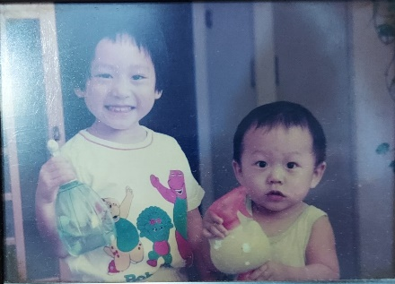Building on the basic skills learnt during the sensorimotor stage, the preoperational stage supplies foundation for symbolicalness in developmental growth for toddler me.

Examples of such developmental growth are:

* + - * Beginning to think symbolically and using words and pictures to communicate
      * Inability to empathise and can only view situations and outcomes one-dimensionally
      * Ability to build upon language speaking skills, albeit with difficulty. Struggles to adapt upon said skills and thought process is not flexible  
        (Cherry, 2020)

The parenting style during this period was authoritative, where my parents nurtured me, and were responsive and supportive. However, it didn’t last for long.

Figure 2: Three Year Old Justin

Concrete Operational Stage: 7 – 11 years old



Whilst school age me is busy with his chopsticks, let us dive into the concrete operational stage. As I was building and developing my linguistic skills, my adaptability in logic was also growing. I began to understand how to apply my logical reasoning skills to different situations and began to empathise with others.

This resulted in my self-absorbed nature and egocentrism slowly beginning to fade away as life became more colourful for me. I began to view the world with not only me in it.

Such examples include:

* + - * My thinking became more logical and organised, but still very concrete
      * I was able to understand the concept of conservation, in that knowing that the quantity of an object doesn't change if it's been altered   
        (Team Lovevery, 2020)
      * I began to be able to apply inductive logic and reasoning into my decision making. Inductive logic is the form of reasoning in which inferences and general principles are drawn from specific observations and cases.

(APA Dictionary of Psychology, n.d.)  
(Cherry, 2020)

Figure 3: Eleven Year Old Justin

Contrary to the positivity seen in the picture, the parenting style during the concrete operational stage devolved into Authoritarian Parenting, often referred to as Asian-Style parenting or Tiger Mum Parenting. The authoritarian parenting style consists of high expectations yet little responsiveness.

This resulted in an extremely high-stress environment, where the high expectations fed into the authoritarian-like regime on the desire to control obedience, discipline, and outright behaviour. The effects of such a parenting style meant that it fuelled a lot of anger within young Justin. To add to that, there wasn’t any justification, rationale, or reasoning behind these parenting methods.

The fact that it devolved too quickly without rhyme or reason made it more of a reason to feel angry. And not only did I feel angry, but this also skewed my perception and view on how I viewed authority figures. It led me to distrust and scepticism of social rules and norms. It did not allow me to develop in the way that would have best nurtured my inquisitive personality; it was all shut down instantly, consistently.

The authoritarian parenting style made me selfish and goal-oriented. It devolved my principles, causing me to have a strong sense of self-justice yet be willing to do anything to get what I wanted, or what I felt was ‘right’. Looking back now, more than half a decade later, it really is surprising that I took the morally ‘right’ route, instead of following the negativity and hate and further devolving into a sociopathic nonce.

Either way the wind blows, authoritarian parenting is a no-no, and I strive to ensure that the precedent gets broken when it comes time for me to step up to the mantle of what it truly means to be a parent.

Formal Operational Stage: 12 years old and up

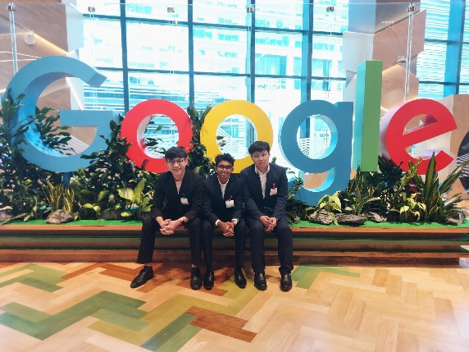Alas, we reach the final stage of cognitive development. We come to the present-day schooling Justin. The formal operational stage. This is where there is an increase in the use of logic, deductive reasoning and the understanding and manipulation of abstract ideologies.

Such examples are:

* + - * + Begin to think in abstract thoughts and ideas
        + Ability to hypothesise and discuss different thought processes and ideas
        + Begin to think and critique moral, ethical, philosophical, and principle-based concepts that require in-depth reasoning and thought abstraction.

Figure 4: 18 year old Justin

So, which stage did I choose? I chose the Formal Operational Stage.

And it's simple to say,

"Oh, Justin, you chose that because it's what you're going through right now, making it a lot easier to write about and discuss."

But isn't that the point? Isn't it true it ultimately comes down to our growth?

My character and personality development are the result of decades of experiences and lessons.

It is clear from a closer look at the parenting style used in the Formal Operational Stage that it is no longer Authoritarian or Authoritative. In reality, it is Neglectful Parenting.

What is Neglectful Parenting? It refers to the lack of involvement in the parenting of the child. This can manifest as a lack of interest in the child, complete disregard for them, or minimal to no demands at all. This emotional distance results in no warmth, love, affection, or even attention toward the child.

What effect did this have on me as a person? This resulted in me having difficulty committing and forming attachments in life. In addition to this, the lack of boundaries present limited my success in social interactions. This left me feeling lonely and awkward with others.

I ceased to rely on anyone else for solace. I started to not include my friends or family in my life because there wasn't much point in them being there in the first place. This lack of emotional and physical support led to me simply becoming selfish.

But what gives? Why did they do such a thing? The most heart-breaking aspect of it all was that they chose to be abusive and neglectful parents, and that decision was not the result of circumstances outside of their control. It came from choice.

The choice to behave in this manner was made consciously. They actively chose to prioritise themselves over their own flesh and blood. They chose to prioritise themselves over their own children, and actively chose to neglect their children.

Emotional unavailability is one of the main causes of such issues. These problems are sparked by the fact that people are still having children despite not even being able to manage their own problems. Asian societies often ignore the inability to address emotional needs. This should not be the case. The child ought to be able to take for granted having a roof over his head, food to eat, or clothes to wear. But the neglectful parenting sometimes got so bad to the point where I was waking up in the morning wondering whether I even had money to eat.

What is the lesson here? If you can’t make time, don’t have children. Asian elders frequently pressure young adults to get married and start families right away. But almost all young couples are unaware of the responsibilities, obligations, and expectations that come with raising a child.

As they say, hindsight is always 20/20. And honestly, if I had the ability to go back in time and speak to 11-year-old Justin again, I would tell him to hold onto his hat, as it’s going to be a bumpy road ahead. Would I change anything if I could go back in time? No.

I don't hold myself accountable for their actions. It’s funny how we’re supposed to look up to our elders. How am I supposed to look up to the household's adult when I have to act the part?

Nonetheless, we must keep pushing. As I mentioned earlier, it is now my responsibility to break this abusive and manipulative cycle. Every parent should aim to parent in an authoritative manner, which is the only parenting style that should be present.

Since there are no second chances in a child's life, there is no justification for settling for second best. Each stage of cognitive development is a culmination, and none of them occurs in isolation. If we allow this to go on for future generations, it will all add up and will grow into a huge problem.

If there's one thing I want to tell you, Justin, it's to keep your head high and to avoid looking behind you. We'll keep pushing.

Love,

Justin

**References:**

1. Cherry, K. (2020a). *What Are Piaget’s Four Stages of Development?* [online] Verywell Mind.   
   Available at: <https://www.verywellmind.com/piagets-stages-of-cognitive-development-2795457#:~:text=Sensorimotor%20stage%3A%20birth%20to%202>   
   [Accessed 2 Aug. 2022]
2. Team Lovevery (2020). *Piaget’s 7 conservation tasks and when your child can do them*. [online] Lovevery.   
   Available at: <https://lovevery.com/community/blog/child-development/the-7-conservation-activities-that-can-help-your-child-with-math-and-more/>   
   [Accessed 2 Aug. 2022]
3. APA Dictionary of Psychology (n.d.). *APA Dictionary of Psychology*. [online] dictionary.apa.org.   
   Available at: <https://dictionary.apa.org/inductive-reasoning>  
   [Accessed 2 Aug. 2022]

**Topic 3**

Name: Justin Wong Juin Hng

Admin No: P2112646

Topic Name: How Spotify stands apart from the status quo

|  |  |
| --- | --- |
|  | **Tutor’s Qualitative Comments Only** |
| Content |  |
| Language |  |
| Organisation & Format |  |
| Visuals |  |

**Begin your Learning Journal here:**

Allow us to quickly take a look at a brand that has familiarised itself as a household name. Spotify.

What is Spotify? Spotify is a digital music, podcast, and video service that gives you access to millions of songs

and other content from creators all over the world. (Spotify, 2020)

Spotify works on a subscription based model, offering 4 different types of subscriptions.

As you can see, I am currently under the Family Plan with 5 other people from my household.



But why did I pick Spotify? There are so many other major streaming services available to choose from. Apple Music, Amazon Music, YouTube Music, Deezer. Choices are aplenty. What makes Spotify so special?

I grew up with Spotify. My parents were early adopters of the service, dating way back to the stone ages of the 2010s. As a wee lad, we were constantly bombarded with the ads that Spotify inserted in between our listening sessions.

Figure 1 (Spotify, 2022)

One could say that I’d be able to recognise a Spotify ad from 7 miles away, and another could perhaps say that it was classically conditioned in my sister and me to groan in despair when the ads popped up.

My Perception of Spotify

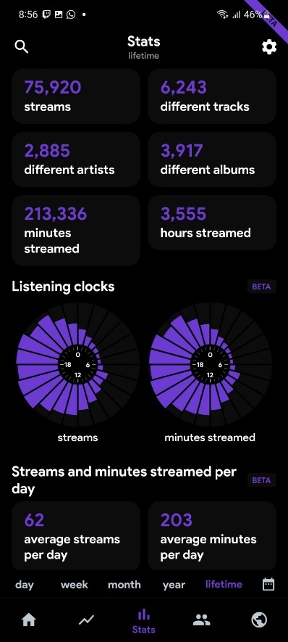

Having used Spotify for over 2 years now and being familiar with the brand name nearing 10 years, it suffices to say that I enjoy the experience. But why? I have a passion for music, as is evident in the picture below.

These are my statistics from my usage of Spotify thus far. I started using it in 2020 and have amounted over 75 thousand streams so far. I’ve averaged 203 minutes per day, roughly 3 and a half hours every day. That accounts for than 10% of my day being spent listening to music!



As the end user, Spotify can constantly keep up with my listening trends whilst being relevant. What does this mean?

Spotify has a yearly event called Spotify Wrapped, where they personalise your top songs that you listened to throughout that year.



Ultimately, my perception of Spotify is unique to me. A decade of brand familiarity coupled with constant innovation from Spotify’s end keep me a loyal user to them as a brand, and the service that they offer.

Figure 2 (Spotify, 2022)

Brands like Spotify earn and re-earn loyalty by doing something others don’t: They connect, engage, and inspire their customers. (Davis, 2015)

Figure 3 (My statistics, 2022)

Why has Spotify has been such a prevalent name and force in the music streaming market? Factors such as their relentless relevance in the music industry coupled with excellent customer personalisation make compelling reasons why they dominate the global market share of music subscribers at 31%. (Eliezer, 2022)

Others’ Perception of Spotify

Majority of people perceive Spotify in a good light. When we analyse the reasons why, we can see that it not only boils down to the service itself, but also what goes on behind the scenes. Spotify also excels in building a brand that is distinctively inspired by engaged employees that deliver the brand promise every day. (Prophet, 2016)

When we explore the service that Spotify offers, it’s clear why Spotify can hang on to a whopping 31% market share.

Features such as:

* Intuitive and interactive User Interface
* Spotify Connect (allows users to connect multiple devices with their Spotify account)
* Intuitional algorithm for song recommendation
* Largest public library available for content

Hence, we can see that the convenience, ease-of-use, and multi-platform availability make it a no brainer choice for its consumers.

However, the drawbacks of Spotify are aplenty. (Sahana, 2022)

* Expensive
* Spotify shows advertisements
* Sound quality is not good for free users
* Spotify is not universally available

We can see that the perception of Spotify from others’ perspective is a lot different as compared to my own, as different people from different backgrounds prioritise different features and services.

Subliminal Stimulus

What is a subliminal stimulus? A subliminal stimulus below the threshold-line for conscious perception but can evoke affective reactions without awareness (Biology Online, 2019) This is applied in Spotify’s marketing campaigns.

We can observe the subliminal stimuli being applied here as a subliminal message.

We can see that the advertisement says that the user is one of Taylor Swift’s top fans worldwide. This subliminal messaging suggests that the user is part of a minority and are *considered unique*. It makes the user feel seen and wanted, thus subconsciously making consumers feel they are important to the artist

By doing so, it builds on Spotify’s identity of hand-crafted personalisation, and encourages the user to start and continue listening to the artist. By doing so, this subliminal stimulus serves a purpose to strengthen or heighten the persuasiveness of advertisements. (Shewan, 2017)



Therefore, this advertisement targets the unconscious perception of the human brain and evokes a reaction to click ‘Play Radio’. This thus encourages the user to listen more of Taylor Swift, thereby using the service for longer and encourages the user to stay on the service for longer, earning Spotify more money.



Figure 4 (Bromwich, 2020)

Rules of Perceptual Organisation

What are the rules of perceptual organisation and how is it applied to Spotify’s logo?

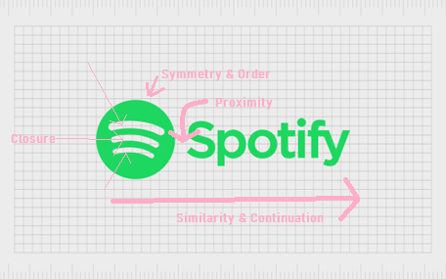

Figure 5 (Fabrik Brands, 2021)

1. Similarity

* We can see that the text is arranged in a similar manner on the same axis, and when the items share visual characteristics, they are perceived as more related than objects that are dissimilar. (CorelDraw, n.d.)

1. Continuation

* We can see the Spotify text is arranged next to the logo, suggesting continuation in horizontal movement. And since we are more likely to see continuous and smooth flowing lines rather than broken or jagged ones, this is because once our eyes begin to follow something, they will continue to travel in that direction until it encounters another item or object. (CorelDraw, n.d.)

1. Closure

* If we are looking at an image, and it has missing parts, our brains will fill in the blanks to complete the image so that we can recognize the pattern. (CorelDraw, n.d.) This is especially present in the 3 curved lines in Spotify’s logo, representing sound waves and connectivity. This is the heart of the service offered by Spotify.

1. Proximity

* When we look at proximity, it indicates that things that are grouped closer together appear as they are more related than things that are spaced further apart (CorelDraw, n.d.) This can be seen in the Spotify logo where the icon itself is placed very closely to the Spotify text, signifying the correlation between the logo and the company name.

1. Figure/Ground

* Figure-Ground is the state in which we view elements as either the object of focus or the background. (CorelDraw, n.d.) However, there isn’t much figure-ground in Spotify’s logo.

1. Symmetry and Order

* The crookedness in the Spotify logo was meant to make the brand appear more human – no-one’s perfect, so perfect lines don’t match the brand’s personality. (Fabrik Brands, 2021)
* Other experts say the crooked Spotify logo tilts slightly towards the right to demonstrate the forward-moving nature of the company and the musical industry. (Fabrik Brands, 2021)

Citations:

- Spotify (2020). What is Spotify? [online] Spotify. Available at: <https://support.spotify.com/us/article/what-is-spotify/>

[Accessed 3 Aug. 2022].

- Prophet (2016). The Key To Spotify’s Brand Relevance: They’re Customer-Obsessed. [online] Medium. Available at: <https://medium.com/@ProphetBrand/the-key-to-spotifys-brand-relevance-they-re-customer-obsessed-99c3d8f7fe78>

[Accessed 3 Aug. 2022].

- Davis, S. (2015). How to Drive Relentless Relevance in a Changing World. [online] Prophet.com. Available at: <https://www.prophet.com/2015/04/how-to-drive-relentlessly-relevant-brand-growth>

[Accessed 3 Aug. 2022].

- Eliezer, C. (2022). Spotify on top as music streaming market diversifies at rapid rate [report]. [online] The Music Network. Available at: <https://themusicnetwork.com/music-streaming-market-diversifies/>

[Accessed 3 Aug. 2022].

- Sahana (2022). 10 Benefits and Drawbacks of Spotify. [online] Tech Quintal. Available at: <https://www.techquintal.com/advantages-and-disadvantages-of-spotify/>

[Accessed 3 Aug. 2022].

- Biology Online (2019). Subliminal stimulus. [online] Biology Articles, Tutorials & Dictionary Online. Available at: https://www.biologyonline.com/dictionary/subliminal-stimulus

[Accessed 3 Aug. 2022].

- Bromwich, J.E. (2020). What Do Those Spotify ‘Top Fans’ Messages Mean?. The New York Times. [online] 27 Feb. Available at: <https://www.nytimes.com/2020/02/27/style/spotify-top-fans-messages.html>

[Accessed 3 Aug. 2022].

- Shewan, D. (2017). 6 Examples of Subliminal Advertising, from Spooky to NSFW. [online] Wordstream.com. Available at: <https://www.wordstream.com/blog/ws/2017/10/24/subliminal-advertising>

[Accessed 3 Aug. 2022].

- Fabrik Brands (2021). Spotify Logo History And The Spotify Symbol Meaning. [online] Fabrik Brands. Available at: <https://fabrikbrands.com/spotify-logo-history-spotify-symbol-meaning>

[Accessed 3 Aug. 2022].

- CorelDraw (n.d.). CorelDRAW Graphics Suite | Free Trial. [online] www.coreldraw.com. Available at: <https://www.coreldraw.com/en/tips/gestalt-principles/similarity/#:~:text=The%20Gestalt%20Principle%20of%20Similarity%20states%20that%20when%20items%20share>

[Accessed 3 Aug. 2022].

**Topic 4**

Name: Justin Wong Juin Hng

Admin No: P2112646

Topic Name: Memorising Content Heavy Electrical Systems

|  |  |
| --- | --- |
|  | **Tutor’s Qualitative Comments Only** |
| Content |  |
| Language |  |
| Organisation & Format |  |
| Visuals |  |

**Begin your Learning Journal here:**

Fundamentals of Computing. FOC. I’d be damned if I ever have to hear that module name again. The whole schtick about FOC was memorisation. Memorising this, memorising that.

I hate memorising. I prefer to do work hands on, I take life as an ‘open-book’ test. I dislike memorisation purely because not only is my memory good, but also because I don’t understand the subject matter at hand.

An easy example is biology. I dislike biology because of the mindless repetition of information. However, what we learn in biology is important, as it forms the core of the subject itself. The vast array of content and knowledge *needs* to be intuitive to us at our first thought. That’s why the medical world is so knowledgeable.

However, the fundamentals of how a computer works *isn’t* important enough for memorisation. So, I guess that’s why I disliked it. The information present in the exam could’ve easily been googled! Why should I memorise it?

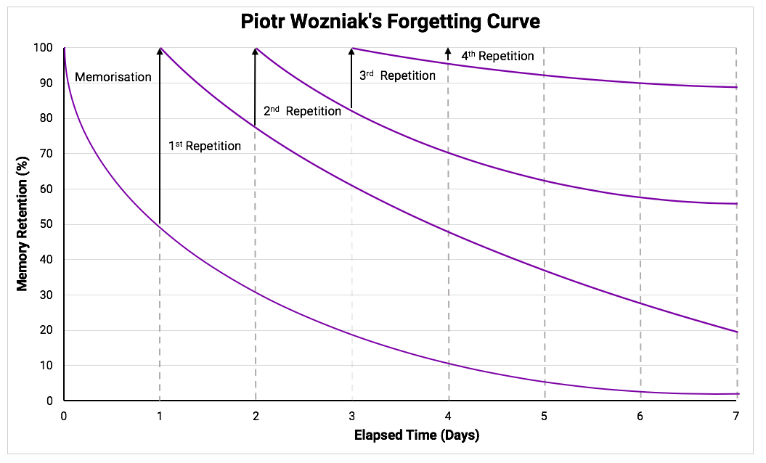Nonetheless, I applied some techniques to memorise the pages upon pages of information. I used methods such as Active Recall and Spaced Repetition to ensure that I memorised as much information as possible, as accurately as possible.

Figure 6 (Wersch, 2020)

Information Processing Model of Memory

1. Encoding
   1. The processing of the FOC questions into my memory
2. Storage
   1. The retention of the FOC questions over spaced repetition and elapsed time
3. Retrieval
   1. The retrieval of the answers for the questions during the exam period

Multi-Store Model of Memory

The processed memory is stored in the long-term storage as the memory is there for more than 1 minute.

If I were to take the test again today, I still probably won’t be able to remember the answers because I simply do not like the content that I was being tasked to memorise

After learning this topic, I would improve my memory by structuring and organising my workflow and information.

I would also utilise Mnemonic Devices.

**Citations:**

* Wersch, J. van (2020). *How to Remember Anything: Active Recall, Spaced Repetition and the Note Taking Fallacy*. [online] Dekked. Available at: <https://medium.com/dekked/how-to-remember-anything-active-recall-spaced-repetition-and-the-note-taking-fallacy-d8e001ada471>   
  [Accessed 4 Aug. 2022].